EXPERIMENT- 5

AIM:-
(i) Download and install nmap. Use it with different options to scan open ports, perform OS fingerprinting, do a ping scan, tcp port scan, UDP port scan, xmas scan etc.
(ii) Detects ARP spoofing using nmap and/or open-source tool ARPWATCH and wireshark. Use arping tool to generate gratuitous arps and monitor using wireshark

THEORY:-
1. Nmap (Network Mapper):
Nmap, short for "Network Mapper," is an open-source and versatile network scanning tool used for reconnaissance and security auditing. It was designed to discover hosts, services, and open ports on computer networks, creating a map of the network's structure.
The primary purpose of Nmap is to provide network administrators and security professionals with a powerful and flexible tool to assess the security posture of a network. It helps identify vulnerabilities, misconfigurations, and potential points of entry for attackers.
Legal and Ethical Use: It's essential to use Nmap responsibly and with proper authorization. Unauthorized scanning of networks is against the law and can lead to serious consequences.
Stealth Scanning: Nmap provides options for stealthy scanning, such as the SYN scan (-sS), which sends SYN packets to open ports without completing the three-way handshake. This reduces the likelihood of detection.

2. Ping Scan:
A ping scan, also known as an ICMP Echo scan or host discovery scan, is a method used to determine the online status of a range of IP addresses. It involves sending ICMP Echo Request (ping) packets to the target hosts and observing their responses.
The primary purpose of a ping scan is to identify live hosts on a network. By sending a series of ping requests, the scanner can determine which hosts are reachable and responsive. This information is valuable for network administrators to understand the scope of their network and for security professionals to identify potential targets for further scans or assessments.

3. TCP Port Scan:
A TCP port scan is a method used to identify open TCP ports on a target system. It involves sending TCP connection requests to a range of ports and analyzing the responses to determine which ports are actively accepting connections.:
The primary purpose of a TCP port scan is to enumerate the services and applications running on a target system. Knowing open ports helps security professionals assess potential vulnerabilities, understand the network's service landscape, and tailor further scans or attacks accordingly.

4. UDP Port Scan:
A UDP port scan is a method used to identify open UDP ports on a target system. Unlike TCP, which uses a connection-oriented approach, UDP is connectionless, making the scanning process different.
The purpose of a UDP port scan is to identify services that use UDP for communication. Common services utilizing UDP include DNS, DHCP, and SNMP. Security professionals use UDP scans to detect potential vulnerabilities in these services.

5. Xmas Scan:
An Xmas scan is a type of TCP port scan where specific TCP flags are set in the packet header to resemble a festive pattern. The flags typically set include FIN, PSH, and URG.
The Xmas scan is used to identify open ports and elicit specific responses from the target system. It takes advantage of certain behaviors in TCP stacks that may treat the packet as suspicious, revealing information about the ports.

6. ARP Spoofing
ARP Spoofing, or ARP Poisoning, is a network attack technique where an unauthorized user sends falsified Address Resolution Protocol (ARP) messages to associate their MAC address with the IP address of a legitimate device on a local network. This deceptive practice allows the attacker to intercept and manipulate network traffic, often leading to Man-in-the-Middle attacks. While ARP spoofing has legitimate uses in network troubleshooting and security assessments, it is crucial to emphasize ethical considerations. Performing ARP spoofing without proper authorization is illegal and unethical, with potential legal consequences.
Nmap Single Target:-
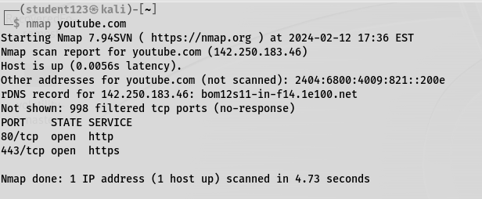

Scan a entire subnet nmap:-
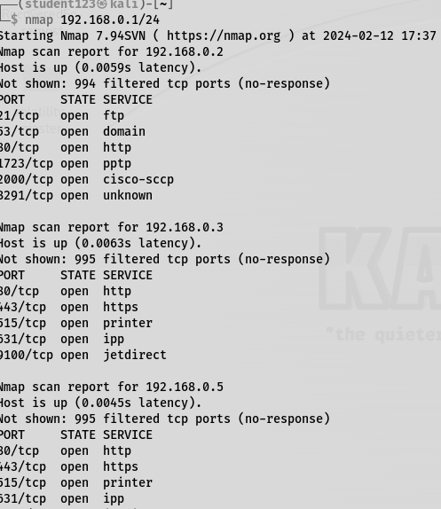
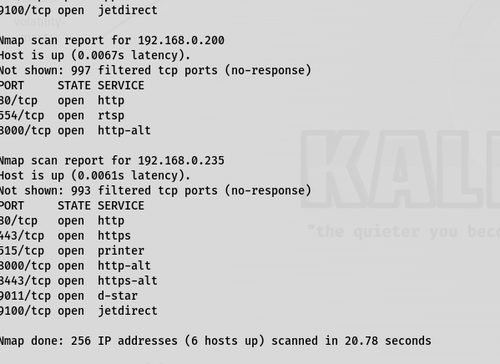

TCP SYN ping:-
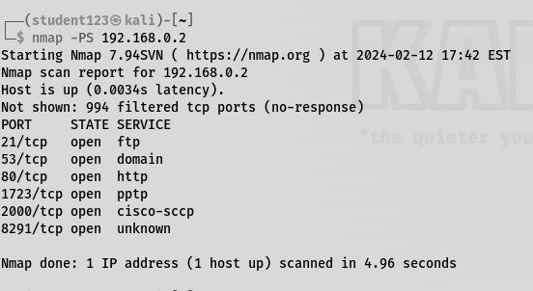

Tcp Ack Ping:-
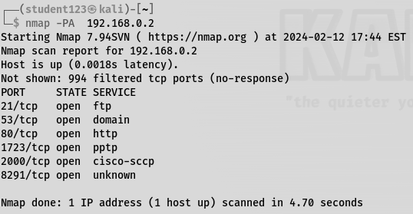
Scan a range:
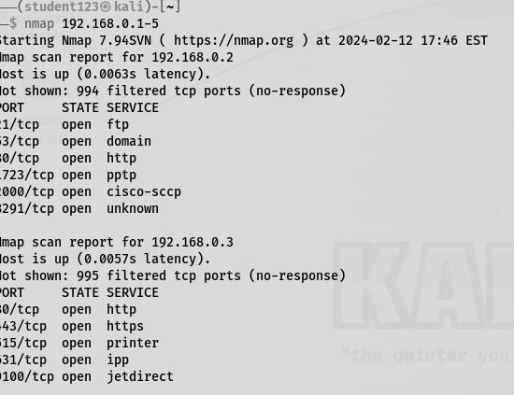
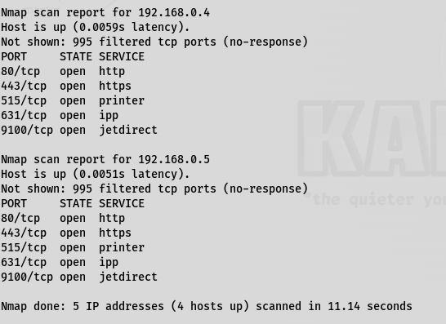
Ifconfig:-
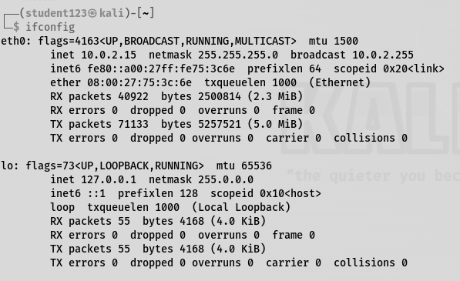

HTTP-
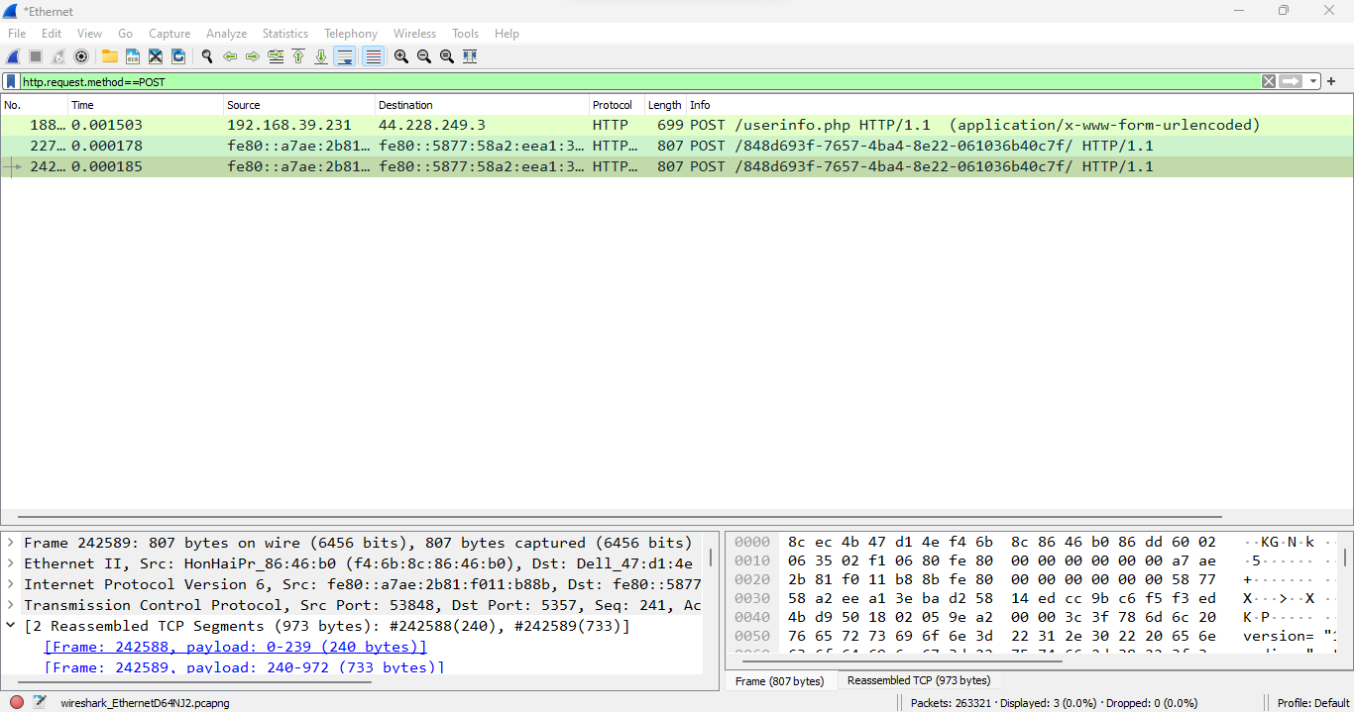

FTP:-

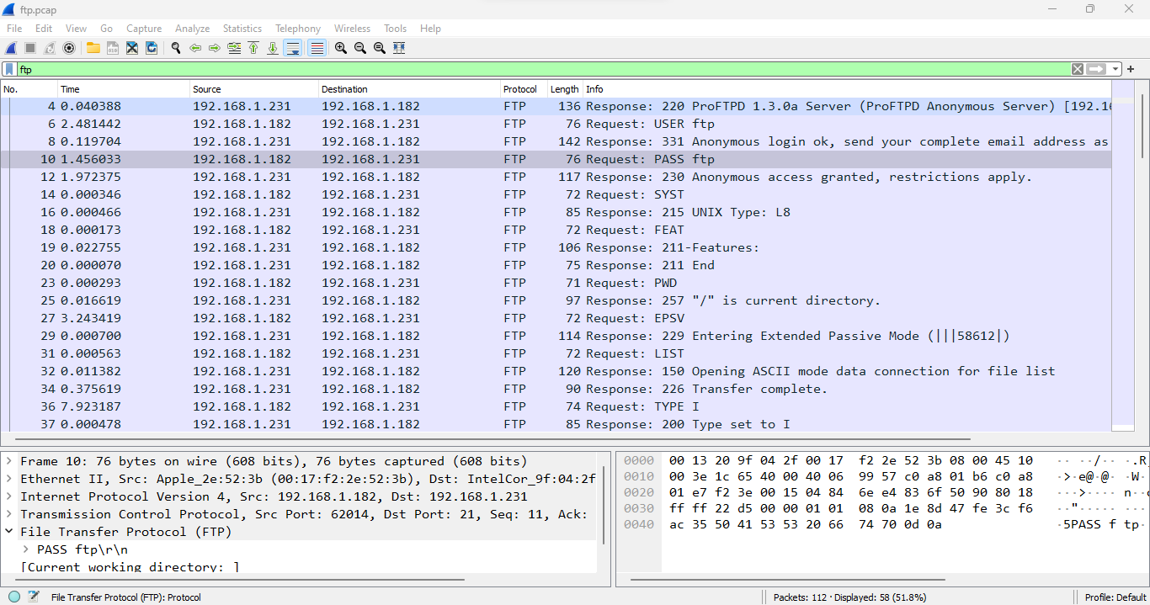

TCP:-
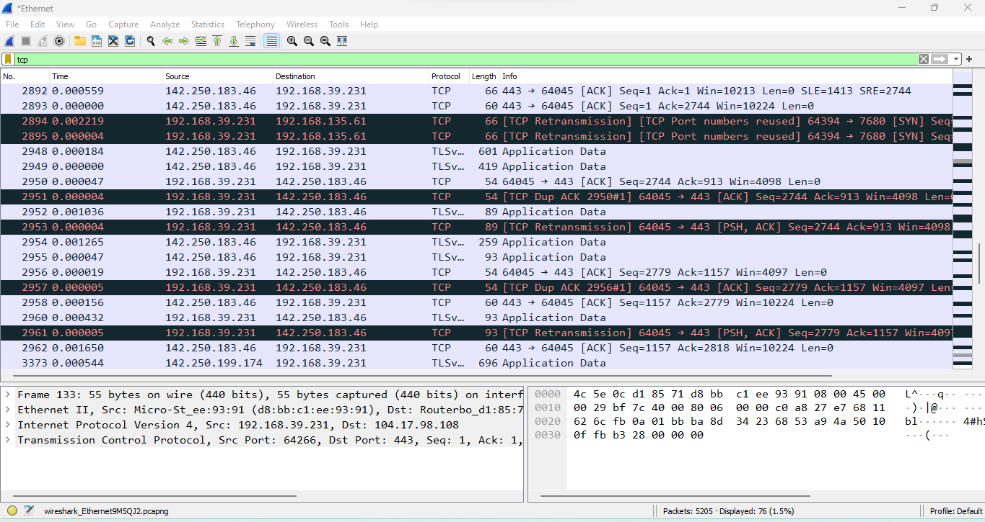

UDP:-

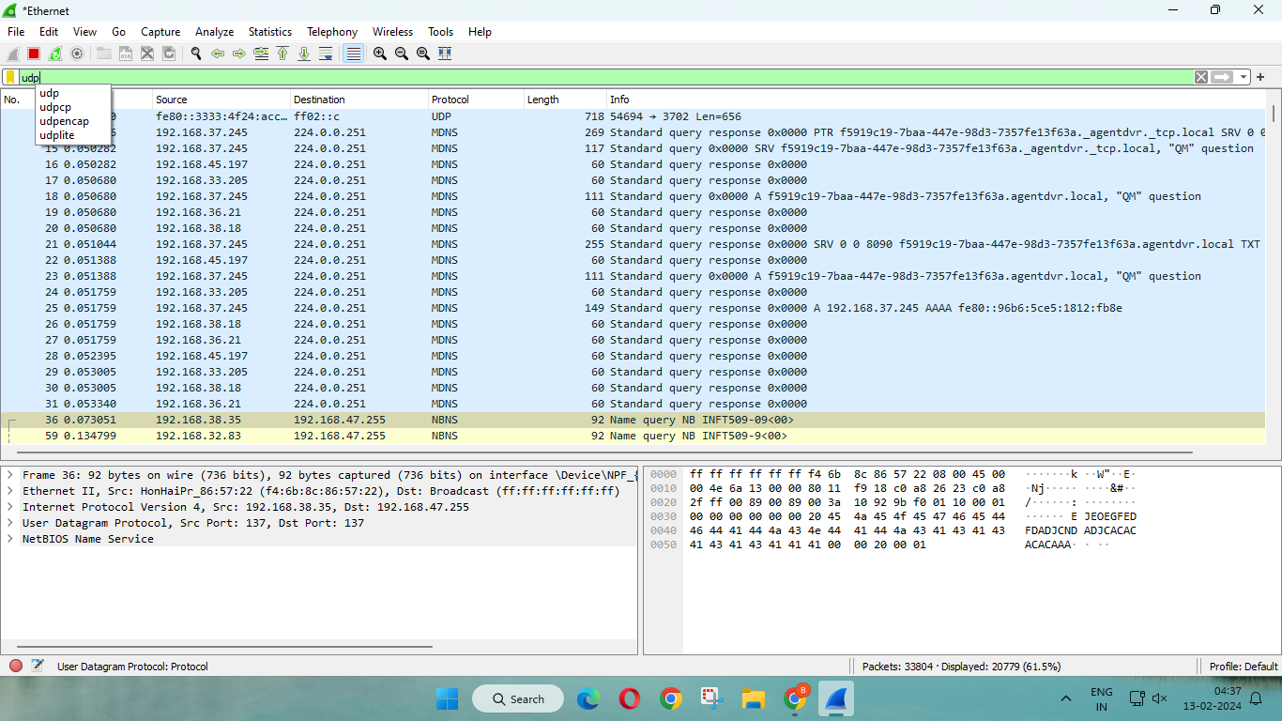

ARP:-

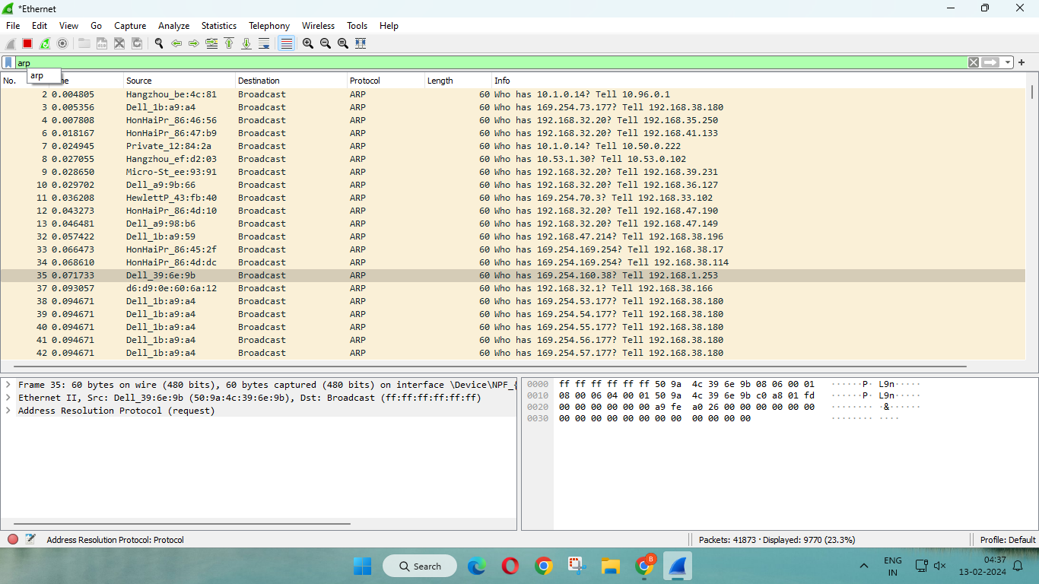

CONCLUSION:-

This experiment involved using Nmap and related tools to conduct a thorough network security assessment. Various Nmap options were explored, including scanning for open ports, performing OS fingerprinting, executing ping, TCP, and UDP scans, as well as the Xmas scan.Detection of ARP spoofing using Nmap, ARPWatch, Wireshark, and the ARP tool highlighted the versatility of these tools in identifying potential vulnerabilities and securing networks. Emphasis was placed on ethical and responsible use, underlining the importance of proper authorization and adherence to legal standards in conducting network security assessments.

